Multi-threaded Data Processing System
Rinku Gopali
University of the Cumberlands
Advanced Programming Languages (MSCS-632-M50)
Dr. Vanessa Cooper
04/13/2025

Abstract
This paper provides details on how a multi-threaded data processing system is developed and how the processing tasks run in parallel using two programming languages, Java and Go. A portion of the system is made up of many worker threads/ goroutines that retrieve shared resources from a queue and operate concurrently on them to write out results to an output file. Through concurrency models, synchronization mechanisms, and error handling specific to each language, the system demonstrates the key differences between Java and Go in how resources and multi-threading are synchronized. This report elaborates on the practical use of synchronization, task management, and exception handling in these two programming environments.
System Overview
Multi-threaded data-processing systems are designed for creating parallelism with the help of threads, or goroutines that run workers to complete tasks from a common queue. Each task itself represents a computational job for execution. The shared resource works as an enqueue where all threads are free to take tasks to finish their work. An important attribute of the system involves artificial delays in computations to simulate real processing times. Each worker fetches a task from the queue, executes it, and saves the output results in a common file system. This system protects against double processing of tasks while ensuring that data is safeguarded against loss and duplication during task execution. Thread-safe techniques implemented in Java and Go allow the system to manage concurrent accesses to shared system resources successfully.
Concurrency and Exception handling in JAVA
The Java implementation makes use of standard Thread classes to support concurrency, wherein each worker is a different thread that executes the run() method of a Runnable task (Gustafsson & Nederlund Persson, 2024). Mutual exclusion on the shared task queue by use of a ReentrantLock ensures that workers can safely access tasks. The results are written to a synchronized list to avoid causing concurrent modification errors. The system makes use of a BufferedWriter to write the processed results into a file. All operations on files are wrapped inside try-catch blocks, which can catch IOException errors that the code may throw while performing tasks related to the file system. The program handles possible interruptions and ensures that when threads try to access an empty queue, they return null instead, enabling them to end without causing any errors.
Concurrency and Exception Management in Go
Concurrency using lightweight threads (goroutines) is one of the features provided by the Go implementation (Lumba, 2023). It helps to process tasks concurrently. All the worker functions have been sent buffer channels so that they accomplish concurrency automatically, freeing the programmer from having to lock resources explicitly like Java applications. The results are appended to a slice and writes are thread-safe to this slice using a sync. Mutex to avoid data racing situations when multiple goroutines write their output. The Go version claims that all file options, such as os.Create(), check through the error, and implement proper error returns with it as well run using defer as well to close handles. The program also uses a sync.WaitGroup to wait until all goroutines terminate, after which the main function will terminate, and hence the program will not terminate until all tasks have completed processing.
Comparison: Java vs. Go Concurrency Models
Java programmers must handle their threads manually and supplement their code with ReentrantLock synchronization tools, although they mainly rely on try-catch blocks for standard error handling. Go implements concurrency using goroutines and channels, which offer users simpler overall concurrency management with fewer errors. Error management in Go occurs through a functional method by letting functions return errors that developers must manage explicitly.
The development of Go-based concurrency models proved easier and needed fewer repetitive sections of code. The Java language provided developers with robust control while exposing higher potential risks of complexity and server deadlocks that focused on insufficient management. The implementations prove successful by ensuring secure execution of concurrent programming with synchronization features in addition to logging mechanisms and exception management.
Screenshots
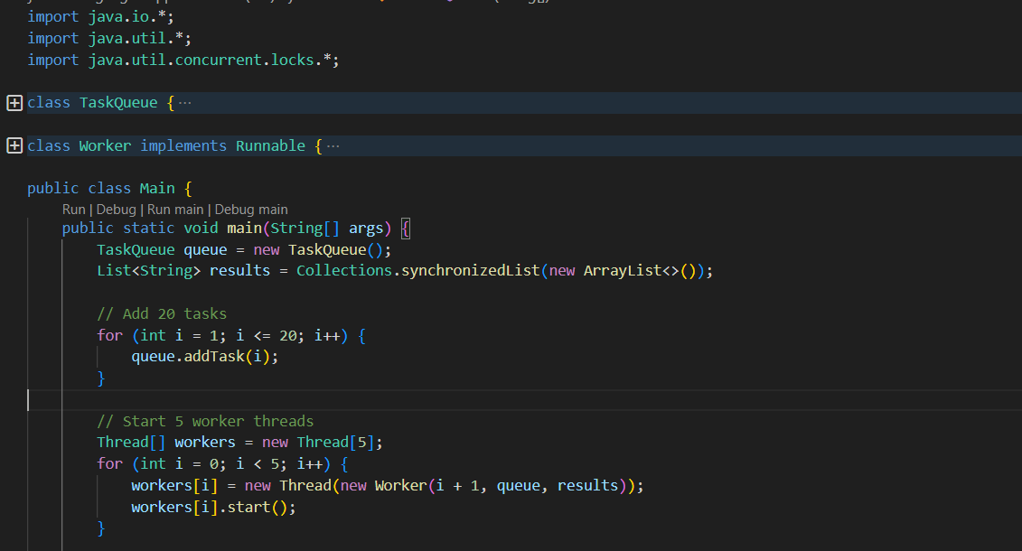Figure 1: JAVA code
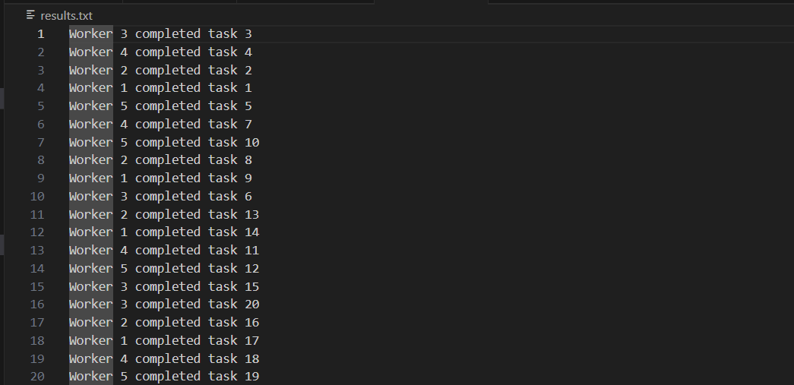Figure 2: JAVA code output
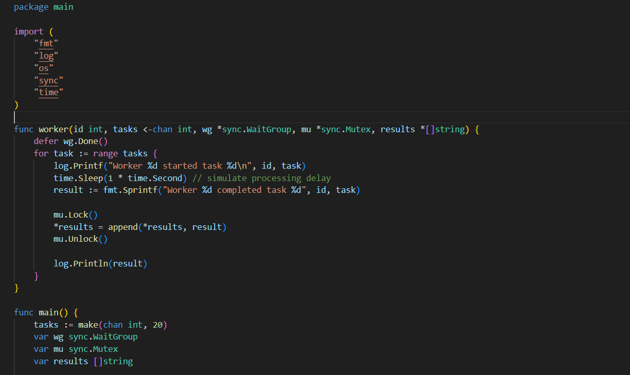Figure 3: GO Code
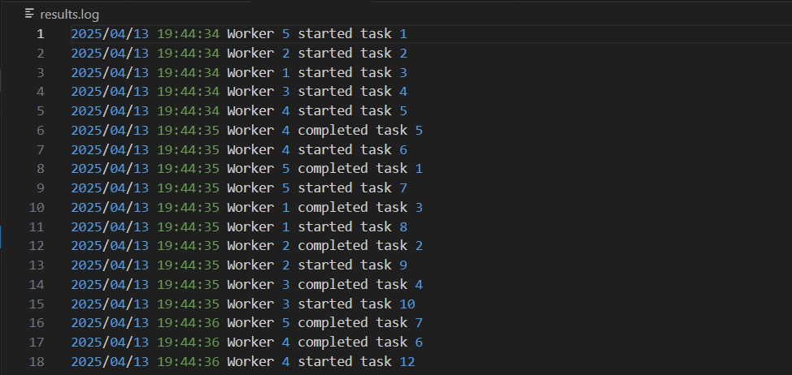Figure 4: GO Code Output
Github Link: https://github.com/rgopali25573/Assignment-6-Multi-threaded-Data-Processing-System.git
References:
Gustafsson, E., & Nederlund Persson, O. (2024). Comparison of Concurrency Technologies in Java. LU-CS-EX. https://lup.lub.lu.se/luur/download?func=downloadFile&recordOId=9166685&fileOId=9166687
Lumba, S. (2023). Enhancing Microservice Performance: A Comparative Analysis of Thread & Fiber Model (Doctoral dissertation, Dublin, National College of Ireland). https://norma.ncirl.ie/7088/1/surajlumba.pdf

